The Frontier® Kettle Company

The Frontier® Kettle Co. claimed its stake in the far southwest corner of the Salt Lake Valley and was created to build an extremely attractive, high-functioning, wood burning fire pit that will outlast its owners.  There is no other suspended kettle that is built as stable, secure, stronger or better.

Scott Fitch & The Inspiration Behind The Frontier® Kettle

Having married into a third-generation family of full-time metal craftsmen, over thirty years ago, Scott was instantly hooked and fascinated with the concept of shaping and attaching metal to metal with molten material and cutting metal with gas or plasma. The permanence, strength, and the evocation of stateliness was, and still is, impressive. Loving the outdoors, a good bonfire and or BBQ, Scott has taken the classic and timeless frontier-style tripod kettle set-up, and beefed (pun intended) it up into a modern-day display of form and functionality. That perfection is registered in the United States Patent and Trademark Office as the Frontier® Kettle. Designed, manufactured, and fabricated, in the outskirts of a small, twenty-first century, western frontier city, Scott has bent, rolled, cut, and welded steel into a classic design with a modern-day flare. Scott chose to use the National Mammal, the American Bison, as part of his logomark, paying dual homage to the tripod-hung kettles of yesteryear, the bison, and their role in America’s history and culture.

Distinguishing Frontier® Kettle Features

• We make our own chain out of 1/2" solid steel that is attached permanently to the kettle handle - there is no way the attachment point can slip down the handle - permanent chain to handle attachment is superior Frontier® Kettle Co, engineering. The massive and super attractive chain loops are attached securely underneath the tripod head on a 1/2' thick steel hook. This attachment allows kettle height adjustment from underneath the head with ease and keeps the tripod head clean and clutter-free.

• The Frontier® Kettle's handle is bolted onto the kettle basin for stability as well ease of removal for transportation if inclined.

• The Frontier® Kettle has "fins" welded inside the basin to stably hold the removable lower charcoal and upper grilling surface grates - placing both of the grates inside the basin allows one to preferably cook inside the kettle, not outside or on top of the kettle basin. The charcoal grate is one piece and the grilling grate is two pieces to allow for charcoal adjustments whilst grilling if needed. (Both the charcoal and grill grates should be removed when used as a fire pit.)

• A Frontier® Kettle’s tripod stands at 6' tall at the center and each leg is 7' apart from the other on the ground. The legs are 3" in diameter DOM steel and have a thick sidewall that "nests" perfectly inside the tripod head's thick leg sleeves. Each of the three legs have a 1/4" steel plate “foot” welded permanently at the base.

• The Frontier® Kettle basin is 1/4" steel that has been pressed into shape; it is 37" wide and 19" deep.

• The tripod head has three gusset's that conceal the chain hook as well as add structure to the head: one gusset is branded "The Frontier® Kettle Co.," another displays the Frontier® Kettle "Bison" trademark, the third is blank but can have a company brand, family name, etc. cut into it for a fee.

• The 19 gauge steel lid helps keep any rain or snow out of the basin when the kettle is not in use.

• Each Frontier® Kettle comes with two, different length, 1/2" thick "S" hooks that can be placed securely into the handle mount for hanging Dutch ovens, pots, or the like, inside the kettle basin, allowing additional cooking options.

• The entire Frontier® Kettle is made of 100% American steel; it is stately and heavy, fabricated in our Salt Lake City, Utah location, and engineered as something to hand down from generation to generation.

• A Frontier® Kettle comes in two finish options: a high-heat black powder coating or in a beautiful, naturally occurring, iron oxide finish.

• Every Frontier® Kettle is sold as “Complete,” meaning everything is included, no need for add-ons when you order; you get everything we make – included.

• A Frontier® Kettle is built to last for generations - its actual life expectancy is yet to be determined.

Why A Frontier® Kettle

Whether your goal is to elicit the look, feel of a peaceful retreat or a central gathering place, the aesthetic and function of a Frontier® Kettle cannot be surpassed – even when not burning wood, a Frontier® Kettle is a beautiful piece of architecture standing simply on its own.  For those times you want to feed yourself, your family, or your guests, insert the charcoal grate then the grilling grates, and your Frontier® Kettle doubles as a full-functioning charcoal grill – with a massive amount of cooking surface.

Pricing

• Black, High-Heat Powder Coated Frontier® Kettle, Complete: $2,100

• Raw Steel (will “rust off” & develop that beautiful natural iron oxide finish over time) Frontier® Kettle, Complete: $1,800

Shipping

Frontier® Kettles are large, heavy, and will ship securely packed in two wood crates, our door to yours, via a liftgate courier truck. Shipping costs vary by location. Call or email us for an accurate, best rate shipping quote.

Delivery

Free delivery in Salt Lake and neighboring counties.

Contact

801-864-3535

[scott@frontierkettle.com](mailto:scott@frontierkettle.com)

Notes for Spencer:

• What can I do for email contact? Do I have a tab called: Write Us A Message – like pand.co (Different or also an email address?)

• Also, I’d like to see if you can point these domain names / URL’s to [www.frontierkettle.com](http://www.frontierkettle.com):

[www.cowboykettle.com](http://www.cowboykettle.com)

[www.cowboykettles.com](http://www.cowboykettles.com)

[www.frontierkettlecompany.com](http://www.frontierkettlecompany.com)

• My competition is Cowboy Cauldron. You can see his website here:

[www.cowboycauldron.com](http://www.cowboycauldron.com)

• Colors:

Black and that copper / gold color you can see in the Bison Logomark and Frontier® Kettle Logotype files. I don’t know the Pantone Number of that copper / gold color. When Jared made the files he used a gradient, which I like in those marks but if you are using a color in the site’s text, I’d like a solid color. I have a HEX color underneath the ALBUM graphic if all else doesn’t work. See the ALBUM Surf site / reference below:

• This is a rad site and you can use the ALBUM copper / gold color in their black and white header – if you can capture it with an eye dropper: https://albumsurf.com/

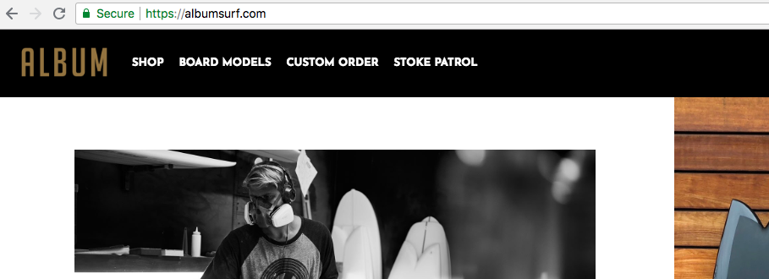

• You can also use HEX #A8764B if that’s easier, I think it’s pretty close to the solid color in ALBUM’s site

